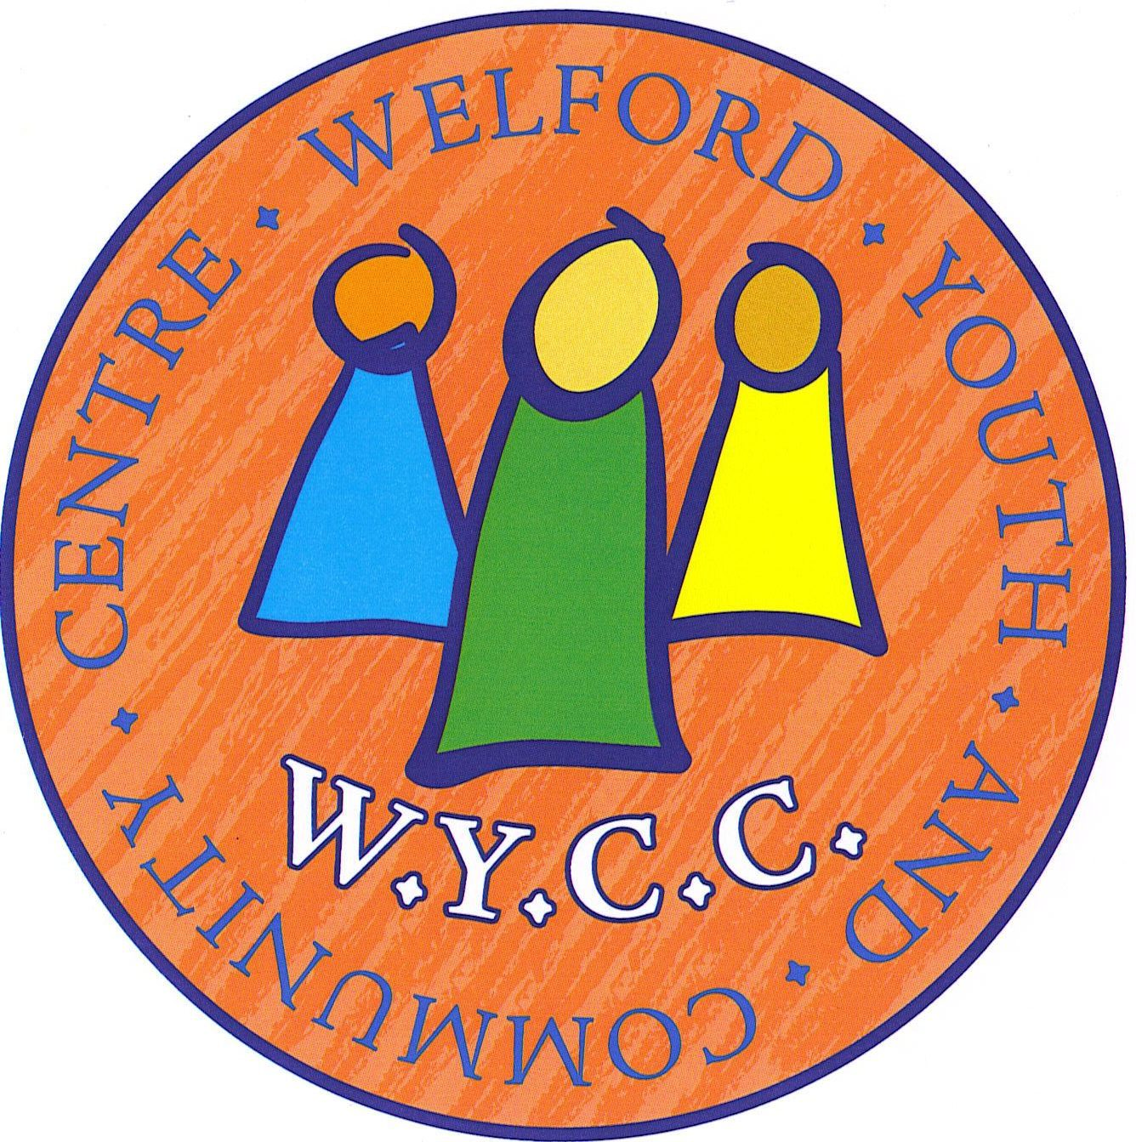
Welford Youth and Community Centre
Conditions of Hire and Information for Hirers

Safety
In the event of a fire, the Hall should be evacuated in an orderly manner using the appropriate exits, and the Fire Brigade called by dialling 999

Power circuits
The power points are timed to turn off at 11.45pm. Please warn your guests, band or disco of this.

Contacts
A list of contact numbers is situated in the Hall. These are intended for emergency use only.

Display of materials /banners / signs etc.
UNDER NO CIRCUMSTANCES SHOULD ANYTHING BE ATTACHED TO THE WALLS OF THE CENTRE EITHER PERMANENTLY OR TEMPORARILY (eg by the use of such materials as blue-tac, sellotape or drawing pins)

Car parking
The road outside the WYCC is a public road and must not be obstructed. Cars are not allowed inside the gates. CARS MUST NOT BE PARKED INSIDE THE GATES OR ON THE PLAYING FIELD. (There are no time restrictions on roadside parking.)The entrance gates and tarmac area must be left clear to allow access for emergency vehicles should they be needed.

Sale of alcoholic drinks
Alcoholic drinks can only be sold if the hirer obtains their own licence from the local licensing authority. A copy of the licence must be submitted to the WYCC Management Committee with the final payment and placed on display during the event.

Village Playing Fields
The centre is situated on the village playing fields which belong to the Parish Council. Hire of the centre does not include the use of the playing fields. Should you wish to undertake any activity on the grassed area (outside the normal use of the field and play equipment) permission must be obtained from the parish council and a copy of the permission given to the booking secretary.

Personal belongings
Personal belongings in the centre are not covered by our insurance policy and therefore you should consider obtaining your own insurance cover especially if your booking is for a number of days (such as wedding hire) and property which is not part of the centre's equipment is left on the premises over night. (The WYCC Management Committee cannot be responsible for any loss or damage to personal belongings)

Consideration for others.
Please can you ensure that guests standing outside the premises have consideration for local residents and users of the village playing field. Glasses should not be taken outside due to the risk of injury to users of the playing fields from broken glass. Please ask your guests to leave quietly at the close of your event. Car doors banging and loud talk in the vicinity are disturbing to our neighbours. Please ensure that your guests respect the caretaker when they return to lock the centre and leave when requested to do so.

Clearing after your event
Please leave the Hall as you would wish to find it – CLEAN AND TIDY, ALL RUBBISH TAKEN AWAY. Table tops should all be wiped clean before stacking them away and worktop surfaces etc. in the kitchen wiped clean..

Return of Deposits
If it is considered that the hirer has not abided by our bookings conditions, that the hall was not left in a suitable condition (eg due to damage, rubbish left, an unacceptable level of mess / dirt etc.) or if the caretaker has had difficulty clearing the centre at the end of the event due to guests refusing to leave your security deposit will not be returned.

Welford Youth and Community Centre, Registered Charity No: 1104974

